Water Quality
A clean water supply is vital to the health and wellbeing of the Tenterfield Township. Water undergoes regular and thorough testing at many points of the treatment and distribution system. Water samples are sent to accredited laboratories to ensure residents have a safe and secure drinking water supply.
Good rains and continued rainfall in January to with flooding in October and November 2021 continuing into October 2022 that have seen the dam overtopping November to January 2023 has seen a decrease in rain, March and May 2023 with the dam stopping overtopping. As a result, we have seen a decrease in water quality and made the need for pumping water from the bores to be put on hold. The RO plant has been returned.

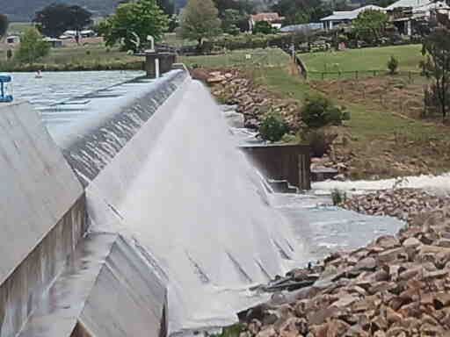
Figure 1: View of Dam Wall October 2022

Occasionally you may notice your water is a little different to usual. Read below for our recommended water quality solutions.
- Discoloured water
Discoloured or cloudy water
Discoloured or cloudy water is usually because of a change within your water pipes. An increase in water flow rate or swift change in direction of water flow in the pipes can stir up sediment. The sediment makes the water look discoloured but is harmless, and safe to drink.
What to do
To clear up the discolouration try running a garden tap closest to your water meter for around 2 minutes and then see if the water is clear when run into a glass. Remember to catch the running water in a bucket to use on your garden.
If the water doesn't clear, contact us via email Coucnil@tenterfield.nsw.gov.au
White water
When air is trapped inside pressurised water pipes, it is converted to tiny air bubbles which gives water a white or milky appearance. This water is still safe to drink.
Air can enter the water supply causing the discolouration during repairs to the pipe network.
What to do
Catch water in an open container and it will become clear within a few minutes. The bubbles will clear from the bottom of the glass upward

- Hard water
Hard water is caused by a higher than usual concentration of calcium and magnesium salts in water. Water hardness levels are monitored on a regular basis in conjunction with Laboratory Services and reported as mg/L (milligrams per litre) of calcium carbonate.
- Taste or smell of chlorine
The water is safe to drink. The smell will disappear simply by leaving a jug of water uncovered in the fridge for a short period of time.
- 'Dirty' tasting and smelly water
The water is safe to drink. If there is an odour or 'dirt' in the water, flush the tap for approximately 1 minute before using. This will flush the pipes out.

Tenterfield Drinking Water Health Card
Health Cards will be prepared monthly and will report how our drinking water meets the quality levels set by the Australian Drinking Water Guidelines and NSW Health requirement in key areas.
We test for a range of water quality characteristics, guided by the Australian Drinking Water Guidelines. The guidelines:
- set the standards for good quality drinking water
- outline good practices for operating a water supply system
- help protect public health
- tell us how drinking water should look and taste.
The characteristics are categorised as physical, chemical and microbial.
Physical | Chemical | Microbial
Turbidity | Free chlorine | Pathogens
Total dissolved solids | Inorganic chemicals (dissolved salts) | Cyanobacteria
Conductivity | Organic compounds
pH
Hardness
Temperature
Dissolved oxygen
Colour
Taste
Odour

Our Health Card will be reporting on the following items - based on Australian Drinking Water Guidelines (ADWG) and NSW Health
Characteristics | Unit of measure | ADWG levels
E. coli | MPN/100 mL | not detected in 100 mL
turbidity | NTU | 0.0 to 0.5
true colour | HU | 15
pH | pH units | between 6.5 - 8.5
Total dissolved solids | Mg/L | 600mg/L
fluoride | mg/L | 1.5*
iron | mg/L | 0.3
aluminium | mg/L | 0.2
manganese | mg/L | 0.1

Measures
1 milligram (mg) | 0.001 gram (g)
1 gram (g) | 1000 milligrams (mg)
1 kilogram (kg) | 1000 grams (g)
1 Litre (L) | 1000 millilitres (mL)
1 millilitre (mL) | 0.001 Litres (L)
NTU | Nephelometric Turbidity Units
HU | Hazen Units  (also referred to as TCU (True Colour Units)
MPN | Most Probable Number (MPN) is a method used to estimate the concentration of viable microorganisms in a sample

Water Storage and Usage

Graph 1 Dam % Levels and Consumption

Graph 2 New Data logger Dam % Graph

Feedback

Residents are welcome to report any feedback or changes to their water appearance or quality by emailing council@tenterfield.nsw.gov.au

Links:

Australian Drinking Water Guidelines
NSW Department of Industry supports local utilities (Councils) in providing water supply and sewerage services

Internal Documents:
The following documents can be found on Council’s Internet Page –
Water Supply (includes Water Restrictions)
Drought Management Plan
Water Conservation & Demand Management Plan

